Case 1: Sales Performance Analysis
Company Background
TechSupply Co. is a regional distributor that sells electronics, office supplies, and office furniture to both retail and business customers. Management wants to better understand sales trends, customer purchasing behavior, and regional performance to improve future sales strategies.
You have been hired as a junior data analyst to explore the sales dataset and provide insights. Your task is to use Excel filtering and sorting tools to answer business questions and provide recommendations.
Dataset: use the techsupply_dataset.xlsx
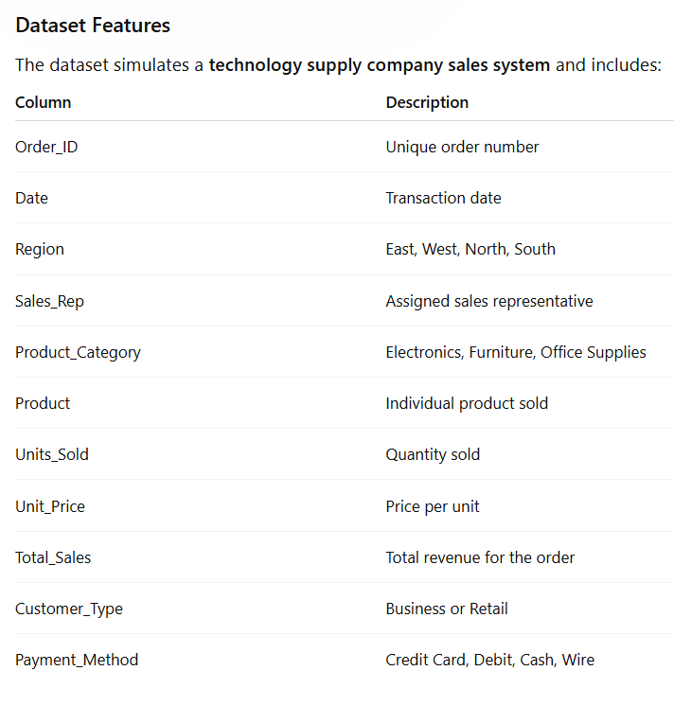

Complete the following 5 tasks.
REGIONAL PERFORMANCE ANALYSIS
Task 1: Use filters to explore sales by region.
- Filter by Region = East
- Sort Total_Sales from Largest to Smallest
Questions:
- What is the largest sale in the East region? The largest is 52950.
- Which product category appears most frequently? It seems that the product category that has the most is electronics.
- Which sales representative appears most often? The sales representative that appears the most is Brown.
CUSTOMER BEHAVIOR ANALYSIS
Task 2: Filter by
- Customer_Type = Business
Questions
- Which product category do business customers purchase most often? The most purchase is webcam.
- What is the largest business transaction? Debit is the most transaction.
- Which sales rep handles the most business orders? Kim handles most business orders.
PRODUCT PERFORMANCE
Task 3: Use filters to analyze Product_Category.
Analyze each category separately:
- Electronics
- Furniture
- Office Supplies
Questions
- Which category appears to generate the highest total sales? Furniture has the most total sales.
- Which specific product appears most frequently? Electronics appears the most frequently.
- Which category tends to have the largest individual transactions? Electronics tends to have the largest individual transactions, with the highest transaction being $34,104.96 for laptops.
PAYMENT PATTERN ANALYSIS
Task 4: Filter by Payment_Method
Analyze:
- Credit Card
- Debit
- Cash
- Wire
Questions
- Which payment method is used most frequently? Debit cards are the most frequently used payment method.
- Do business customers prefer a specific payment type? Business customers may prefer debit cards if they are the most frequently used payment method overall.
- Which payment type is associated with larger purchases? Wire transfers are associated with larger purchases in this dataset, including the largest transaction of $34,104.96 for a laptop.
TOP SALES REPRESENTATIVES
Task 5: Sort by:
- Sales_Rep
- Total_Sales(Largset > Smallest)
Questions
- Which sales rep appears to handle high-value transactions? Kim handled the high-value transactions.
- Which rep appears most frequently in the dataset? Kim appears more frequently in the dataset.
- Which region do they appear to sell in most often? Kim sells most often in the East region
ANALYST RECOMMENDATION
Imagine you are presenting your findings to management.
Answer the following:
- Which region appears to be the strongest market? Strongest market: East region, based on the data provided.
- Which product category should the company promote more? I would promote Electronics more, because it has high-value sales.
- Are business customers or retail customers more valuable? More valuable customers: Business customers, based on the available data.
- What two recommendations would you give the sales manager? Recommendations: Promote high-value electronics.
Build stronger relationships with business customers.

Bonus
Build
- Bar Chart – Sales by Product Category
- Pie Chart – Customer Type Distribution
- Column Chart – Sales by Region
What story does the data tell?

